RKT-A1型系列热风循环风机规格与参数
型号 | 风压  pa | 风量  m³/h | 转速  r/min | 功率  kw | 型号 | 风压  pa | 风量  m³/h | 转速  r/min | 功率  kw
RKT-2.5A1 | 260-200 | 1000-1200 | 1400 | 1.1 | RKT-6A1 | 1296-1060 | 12500-15530 | 1440 | 5.5
 | 156-110 | 750-990 | 910 | 0.75 |  | 585-452 | 9375-11640 | 940 | 2.2
RKT-3A1 | 296-225 | 1500-1800 | 1400 | 1.1 | RKT-6.5A1 | 1676-1283 | 14850-18620 | 1440 | 7.5
 | 206-185 | 1125-1350 | 910 | 0.75 |  | 628-496 | 11137-13965 | 940 | 2.2
RKT-3.5A1 | 420-306 | 2060-2925 | 1400 | 1.5 | RKT-7A1 | 1962-1493 | 17720-22850 | 1440 | 11
 | 157-115 | 1545-2193 | 910 | 1.1 |  | 736-560 | 13290-14950 | 940 | 3
RKT-4A1 | 535-355 | 3260-4620 | 1400 | 1.5 | RKT-7.5A1 | 860-620 | 15600-18200 | 960 | 4
 | 202-133 | 2531-3465 | 910 | 1.1 | RKT-8A1 | 900-600 | 16600-22500 | 960 | 5.5
RKT-4.5A1 | 660-420 | 4810-6550 | 1420 | 2.2 | RKT-8.5A1 | 980-650 | 18300-26500 | 970 | 7.5
 | 248-157 | 3607-4912 | 940 | 1.5 | RKT-9A1 | 1045-820 | 22312-31230 | 970 | 11
RKT-5A1 | 836-625 | 6600-8260 | 1440 | 4 | RKT-10A1 | 1320-950 | 25500-38720 | 970 | 15
 | 313-236 | 4950-6195 | 940 | 2.2 |  | 700-900 | 29500-22300 | 720 | 7.5
RKT-5.5A1 | 990-765 | 8650-12000 | 1440 | 5.5 | RKT-11A1 | 850-1050 | 42100-30800 | 730 | 18.5
 | 415-306 | 6487-9000 | 940 | 2.2 | RKT-12A1 | 1160-935 | 35600-49250 | 730 | 22

型号 | 风压（pa） | 风量（m³/h） | 转速  （r/min） | 功率  （kw） | A | B | C | D | E | F | a | b | g | n-φd
RKT-2.5AⅠ | 260-200 | 1000-1200 | 1400 | 1.1 | Φ250 | 300×300 | 390×390 | 200 | 300 | 665 | Φ200 | 20 | 3×117=351 | 12-φ10
 | 156-110 | 750-990 | 910 | 0.75
RKT-3AⅠ | 296-225 | 1500-1800 | 1400 | 1.1 | Φ300 | 350×350 | 440×440 | 200 | 300 | 665 | Φ200 | 20 | 3×134=402 | 12-φ10
 | 206-185 | 1125-1350 | 910 | 0.75
RKT-3.5AⅠ | 420-306 | 2060-2925 | 1400 | 1.5 | Φ350 | 400×400 | 490×490 | 250 | 370 | 765 | Φ250 | 20 | 3×150=450 | 12-φ10
 | 157-115 | 1545-2193 | 910 | 1.1
RKT-4AⅠ | 535-355 | 3260-4620 | 1400 | 1.5 | Φ400 | 450×450 | 540×540 | 250 | 370 | 765 | Φ250 | 25 | 3×167=501 | 12-φ12
 | 202-133 | 2531-3465 | 910 | 1.1
RKT-4.5AⅠ | 660-420 | 4810-6550 | 1420 | 2.2 | Φ450 | 500×500 | 590×590 | 280 | 400 | 842 | Φ300 | 25 | 3×184=552 | 12-φ12
 | 248-157 | 3607-4912 | 940 | 1.5
RKT-5AⅠ | 836-625 | 6600-8260 | 1440 | 4 | Φ500 | 550×500 | 650×650 | 280 | 420 | 870 | Φ350 | 25 | 4×150=600 | 16-φ12
 | 313-236 | 4950-6195 | 940 | 2.2
RKT-5.5AⅠ | 990-765 | 8650-12000 | 1440 | 5.5 | Φ550 | 600×600 | 710×710 | 300 | 450 | 960 | Φ350 | 25 | 4×165=660 | 16-φ15
 | 415-306 | 6487-9000 | 940 | 2.2 |  |  |  |  |  | 900
RKT-6AⅠ | 1296-1060 | 12500-15530 | 1440 | 5.5 | Φ600 | 650×650 | 760×760 | 300 | 450 | 960 | Φ400 | 30 | 5×142=710 | 20-φ15
 | 585-452 | 9375-11640 | 940 | 2.2 |  |  |  |  |  | 900
RKT-6.5AⅠ | 1676-1283 | 14850-18620 | 1440 | 7.5 | Φ650 | 700×700 | 810×810 | 300 | 450 | 1000 | Φ400 | 30 | 5×152=760 | 20-φ15
 | 628-496 | 11137-13965 | 940 | 2.2 |  |  |  |  |  | 900
RKT-7AⅠ | 1962-1493 | 17720-22850 | 1440 | 11 | Φ700 | 750×750 | 875×875 | 300 | 480 | 1130 | Φ450 | 35 | 5×165=825 | 20-φ15
 | 736-560 | 13290-14950 | 940 | 3 |  |  |  |  |  | 1000
RKT-7.5AⅠ | 860-620 | 15600-18200 | 960 | 4 | Φ750 | 800×800 | 925×925 | 300 | 510 | 1065 | Φ500 | 30 | 5×174=870 | 20-φ15
RKT-8AⅠ | 900-600 | 16600-22500 | 960 | 5.5 | Φ800 | 850×850 | 995×995 | 350 | 600 | 1160 | Φ600 | 30 | 5×188=940 | 20-φ15
RKT-8.5AⅠ | 980-650 | 18300-26500 | 970 | 7.5 | Φ850 | 900×900 | 1045×1045 | 350 | 630 | 1280 | Φ650 | 30 | 5×200=1000 | 20-φ18
RKT-9AⅠ | 1045-820 | 22312-31230 | 970 | 11 | Φ900 | 950×950 | 1100×1100 | 350 | 650 | 1330 | Φ680 | 30 | 5×210=1050 | 20-φ18
RKT-10AⅠ | 1320-950 | 25500-38720 | 970 | 15 | Φ1000 | 1100×1100 | 1240×1240 | 350 | 670 | 1480 | Φ700 | 40 | 5×238=1190 | 20-φ18
 | 700-900 | 29500-22300 | 720 | 7.5 |  |  |  |  |  | 1350
RKT-11AⅠ | 850-1050 | 42100-30800 | 730 | 18.5 | Φ1100 | 1200×1200 | 1380×1380 | 350 | 700 | 1680 | Φ750 | 40 | 5×266=1330 | 20-φ18
RKT-12AⅠ | 1160-935 | 35600-49250 | 730 | 22 | Φ1200 | 1300×1300 | 1450×1450 | 350 | 750 | 1880 | Φ850 | 40 | 5×280=1400 | 20-φ18
RKT-A1型系列热风循环风机
产品外形图：
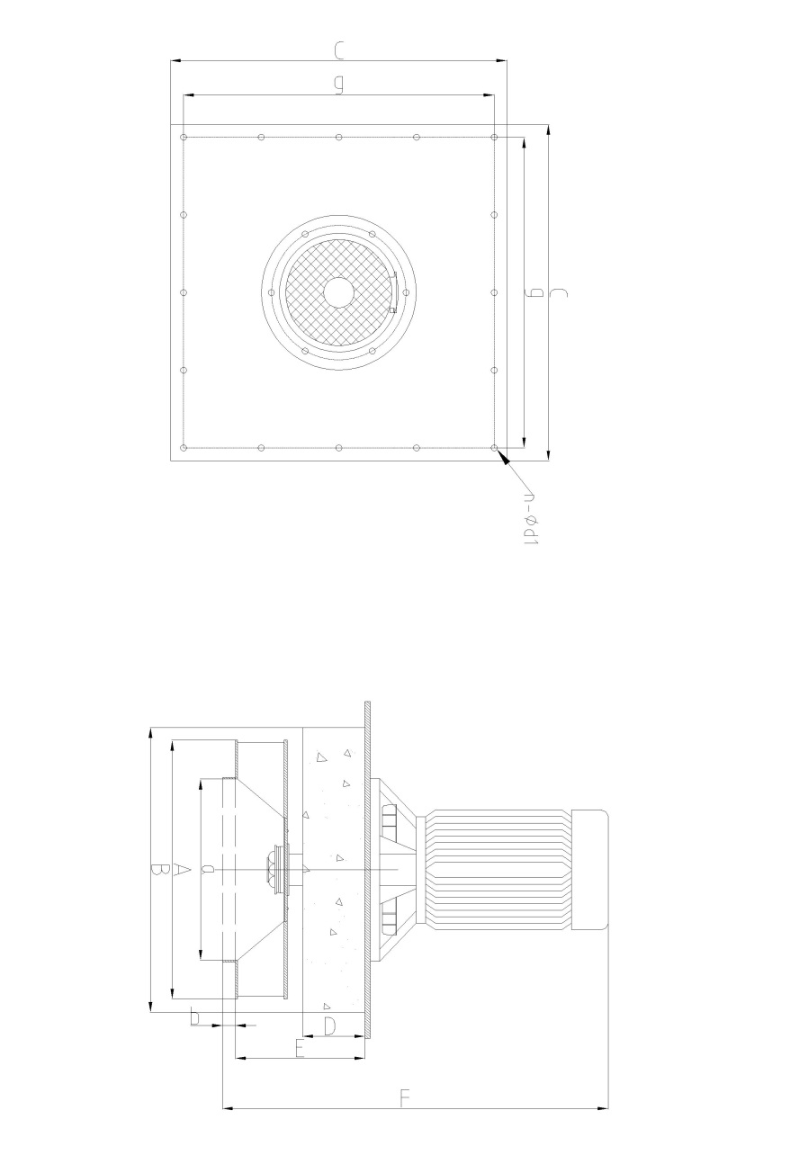
产品特点：是我国目前热处理行业中用途广、功率小、效率高的一种新型风机，风机主要部分采用耐高温材料制造，电机主轴与叶轮直连传动，能适用于≤950℃以下热空气中连续运转，不变形，耐高温长轴电机，不需要任何冷却液，采用定期注入7019-1极压复合锂基脂来保护电机轴承，具有安装省力，维护方便，适用寿命长等优点。
产品用途：本系列风机主要适用于各种玻璃制品退火炉，烤花炉、铝合金时效炉、烘干炉等其他热空气均衡的热处理炉上来解决炉温均匀问题。提高产品质量及效率。

